**SEO-2019**

**Q-1[A]ONE MARK:**

1]SERP stand for- Search Engine Result Page.

2]CTR stand for- Click-Through-Rate:

3]QDF stand for- “Query Deserves Freshness”,

4]when user view the goole search result his eye …. Track create….. F-shaped” pattern with their eye movements.

**Q-1[B]TWO MARK:**

1]what is formational queries?

a. Wikipedia defines informational search queries as “Queries that cover a broad topic (e.g., colorado or trucks) for which there may be thousands of relevant results.” When someone enters an informational search query into Google or another search engine, they’re looking for information – hence the name. They are probably not looking for a specific site, as in a navigational query, and they are not looking to make a commercial transaction. They just want to answer a question or learn how to do something. 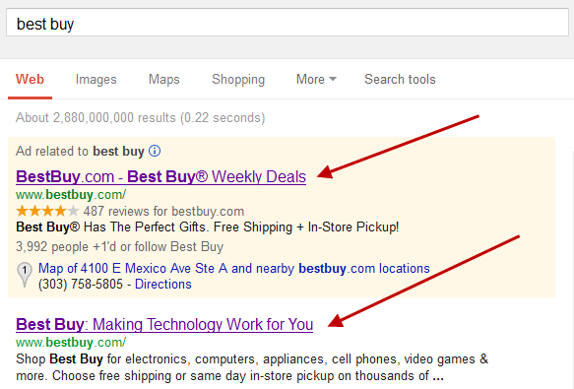

2]what is retrieval and ranking?

A .> Retrieval is basically when the search engine gets a query, looks over it's index database and regurgitates whatever is relevant to the search terms (or keywords). ... When it has found all the relevant ones, it will retrieve it out of it's database and proceed to rank it before releasing it to you.

>Rankings in SEO refers to a website's position in the search engine results page. There are various ranking factors that influence whether a website appears higher on the SERP based on the content relevance to the search term, or the quality of backlinks pointing to the page.

**Q-1[C]THREE MARK:**

1]explain click tracking?

a. Click tracking is a technique used to determine and record what computer users are clicking with their mouse while browsing the Web. The clicking action is then sent and logged by the client, Web browser or server while the computer user continues to explore and click around the ad application or Web page.

Click tracking is an analytics feature that measures and reports where people click or tap on websites, apps, and emails.

Using software or tags, a click tracking tool records mouse clicks and taps (on mobile devices); this data is collected and displayed numerically, visually (heat maps), or by individual sessions (session recordings).

* The benefits of click tracking and how it’s used

Click tracking has a few main applications for analytics and marketing teams: email tracking, link tracking, and UX click tracking—and they all give you access to more meaningful analytics data.

2]explain any three google advance search opearator

a. Advanced search operators are special commands that modify searches and may require additional parameters (such as a domain name). Advanced operators are typically used to narrow searches and drill deeper into results.

II. Advanced Search Operators

intitle: intitle:"tesla vs edison"

Search only in the page's title for a word or phrase. Use exact-match (quotes) for phrases.

allintitle: allintitle: tesla vs edison

Search the page title for every individual term following "allintitle:". Same as multiple intitle:'s.

inurl: tesla announcements inurl:2016

Look for a word or phrase (in quotes) in the document URL. Can combine with other terms.

allinurl: allinurl: amazon field-keywords nikon

Search the URL for every individual term following "allinurl:". Same as multiple inurl:'s.

intext: intext:"orbi vs eero vs google wifi"

Search for a word or phrase (in quotes), but only in the body/document text.

allintext: allintext: orbi eero google wifi

Search the body text for every individual term following "allintext:". Same as multiple intexts:'s.

filetype: "tesla announcements" filetype:pdf

Match only a specific file type. Some examples include PDF, DOC, XLS, PPT, and TXT.

related: related:nytimes.com

Return sites that are related to a target domain. Only works for larger domains.

AROUND(X) tesla AROUND(3) edison

Returns results where the two terms/phrases are within (X) words of each other.

**Q-1[D]FIVE MARK:**

1]different types of queries

a. Navigational Search Queries

A navigational query is a search query entered with the intent of finding a particular website or webpage. For example, a user might enter "youtube" into Google's search bar to find the YouTube site rather than entering the URL into a browser's navigation bar or using a bookmark. In fact, “facebook” and “youtube” are the top two searches on Google, and these are both navigational queries.

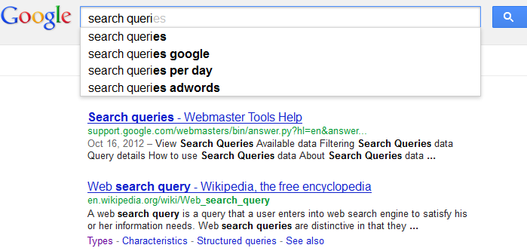

Informational Search Queries

Wikipedia defines informational search queries as “Queries that cover a broad topic (e.g., colorado or trucks) for which there may be thousands of relevant results.” When someone enters an informational search query into Google or another search engine, they’re looking for information – hence the name. They are probably not looking for a specific site, as in a navigational query, and they are not looking to make a commercial transaction. They just want to answer a question or learn how to do something. 

Transactional Search Queries

A transactional search query is a query that indicates an intent to complete a transaction, such as making a purchase. Transactional search queries may include exact brand and product names (like “samsung galaxy s3”) or be generic (like “iced coffee maker”) or actually include terms like “buy,” “purchase,” or “order.” In all of these examples, you can infer that the searcher is considering making a purchase in the near future, if they’re not already pulling out their credit card. In other words, they’re at the business end of the conversion funnel. Many local searches (such as “Denver wine shop”) are transactional as well.

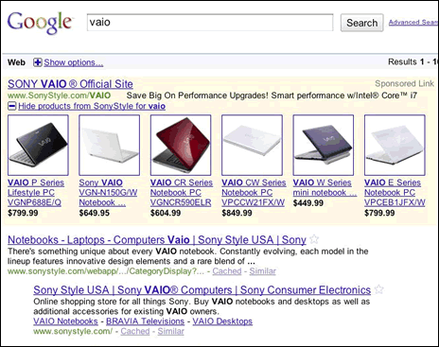

2]explain the layout of search result page.

a.An Overview of SERP Layout

It much depends on what the search query is (What you are searching for). If you are searching for a product which you can buy, then a search engine will show shop results with the [images on the top](https://www.infozub.com/blog/articles/image-optimization/) of the Search Engine Result Page.

[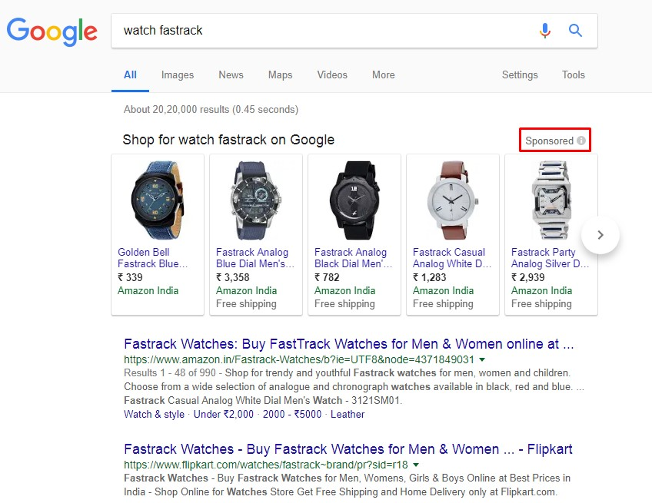](https://www.infozub.com/wp-content/uploads/2018/02/SERP-Layout-Shop.jpg)

If you want your site to get there, then you have to pay to Google (as it is sponsored). Though this result page starts with the paid after that, it starts with the organic results.

**Knowledge Graph:**

If you are searching for information, then you will find different Search Engine Result Page. These information queries will not show paid or sponsored results in SERP. And “***Knowledge Graph***” which is on the right side of SERP will give you lot of information about your query.

[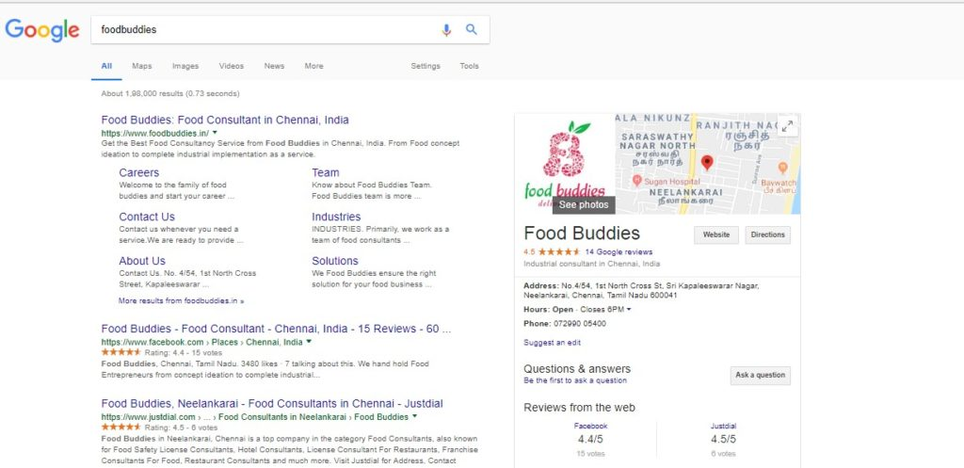](https://www.infozub.com/wp-content/uploads/2018/02/Knowledge-Graph-SERP-layout.jpg)

**Types of Result Page:**

Search Result is the default result page of Google, but you can also see **different types of results on the top of the page like “Images”, “Map”, “Video” and many**. Depending on the type of your query Google will decide which result page fits your query the most and SERP will turn out according to it. You can browse to the different results and apply filters on the search results.

[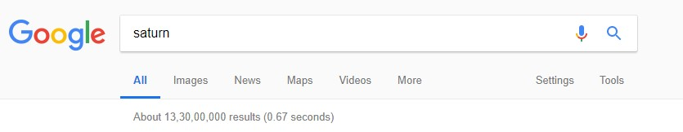](https://www.infozub.com/wp-content/uploads/2018/02/Types-of-Result-SERP-Layout.jpg)

**Ads and Organic Result:**

Google will display both [organic results and paid results](https://www.infozub.com/blog/articles/growth-rate-organic-vs-non-organic-traffic/) on the search engine result page. Most of the search engine users were not aware of the paid results in SERP. Usually, ads will appear either in the top of SERP. To maximum, Google will display four paid ads in the top which is followed by the organic result (10 results will be shown). In some cases, you may also see the ads in the bottom of organic result pages. Google will display two ads to the maximum in the bottom. If it is paid result, you can see the word “Ad” in the link before the link address. As the name says to get your website out there in the paid results you need to pay to Google, for more check out “[Google Adwords](https://www.infozub.com/services/digital-marketing/)”.

[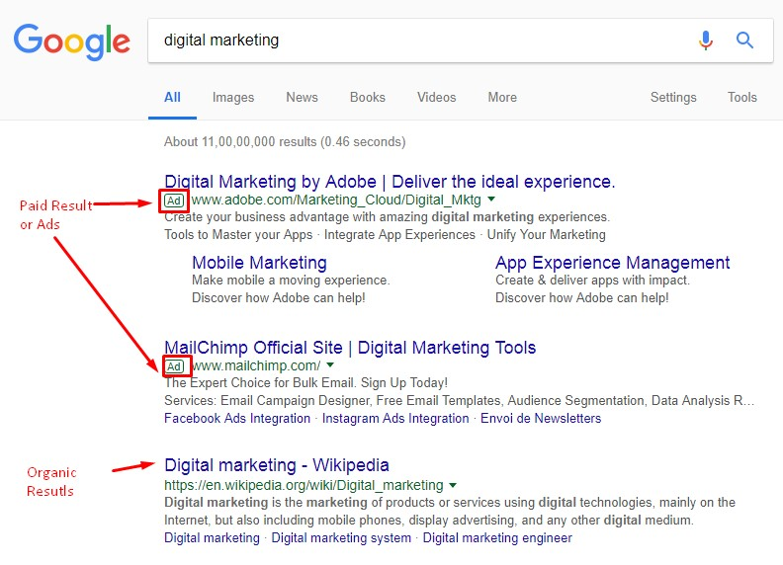](https://www.infozub.com/wp-content/uploads/2018/02/Ads-and-Organic-Search-Reult.jpg)

Organic results which shown in the SERP is the one which fits the most to the search query. It is a non-paid result. To [improve ranking in the organic search](https://www.infozub.com/blog/articles/things-optimize-website-gaining-traffic/), you are left out with only one option which is [Search Engine Optimization](https://www.infozub.com/blog/projects/search-engine-marketing-trends-2018/).

**Snippet:**

A normal snippet consists of Title of the Page, URL/breadcrumbs and Meta description. Google will display the search results in the form of the snippet. Search Engine Result Page will have the number of snippets where each page of SERP will contain ten snippets (Organic Results).

[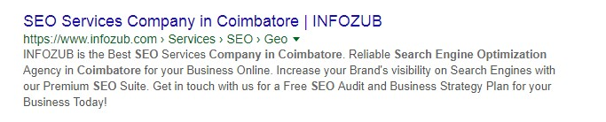](https://www.infozub.com/wp-content/uploads/2018/02/Snippet.jpg)

To differentiate the Title, URL/Breadcrumbs and meta description Google uses the colour code for each.***The title will be displayed in Blue, URL and Breadcrumbs in Green and Meta description of the page in black.***

**Rich Snippet:**

[Rich snippet](https://www.infozub.com/blog/articles/googles-new-testing-tools-rich-results/) contains addition information than the normal snippet. The rich snippet will contain rating on the particular results which would be the review of the person, a product, business and more. Some Rich Snippets will also have images in it. In the below rich snippet which is the result of query about cooking, it has image, rating, review; the time is taken to cook and calories along with the normal snippet details which are the title, URL and Meta description.

[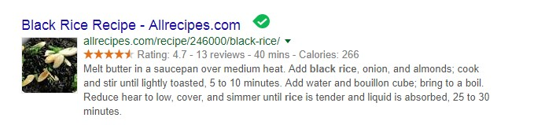](https://www.infozub.com/wp-content/uploads/2018/02/Rich-Snippet.jpg)

**Featured Snippet and Answer Boxes:**

If you get [an answer to your query in the Search Engine Result Page](https://www.infozub.com/blog/articles/customize-webpage-featured-snippet/), then it is featured snippet. It will be displayed on top of SERP above the paid results and organic results.

**Answer Boxes**, [Google will give fetch](https://www.infozub.com/blog/articles/google-bot-works/) answer for certain queries like a weather report, currency conversions etc., and display the result on top of SERP.

[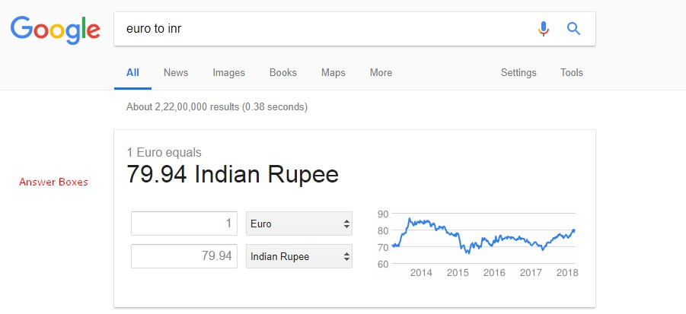](https://www.infozub.com/wp-content/uploads/2018/02/Answer-Boxes.jpg)

As featured snippet and answer boxes where displayed on the top, many people will gets confused between featured snippet and answer boxes usually. If you get an answer along with the [link to the page](https://www.infozub.com/blog/articles/how-linking-affects-ranking/) then it is featured snippet, answer boxes will not have a link, you will just get an answer to your query.

[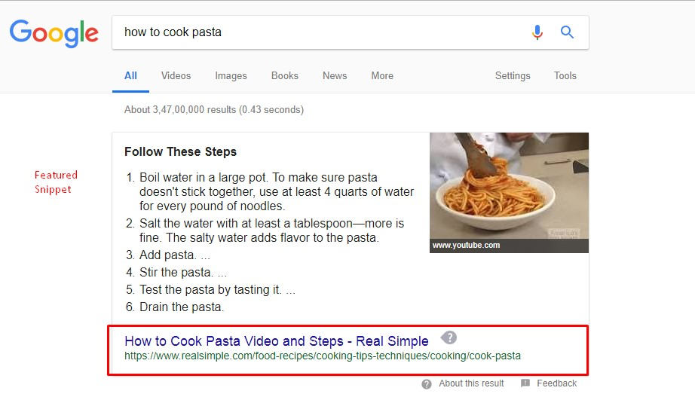](https://www.infozub.com/wp-content/uploads/2018/02/Featured-Snippet.jpg)

**Q-2[A]ONE MARK:**

1]PPC STAND FOR – pay-per-click

2]what is log file tracking?

a. A log file is a actually a file output made from a web server containing 'hits' or record of all requests that the server has received. Data are stored and deliver details about the time and date in which the request was made, the URL requested, the user agent, the request ID address and other ones.

3]ROI stand for- Return on Investment

4]what is doorway page?

a. Doorway pages are web pages that only exist to rank well for particular keyword phrases in search engine results pages (SERPs), and they provide little value to the searcher.

**Q-2[B]TWO MARK:**

1]what is reputation managemnet?points-3.11

a. In short, it's about presenting a brand in the best possible light for a search. SEO Reputation Management focuses on SERP (search engine results page) and keyword performance. It's about finding opportunities to improve rankings of positive content and drown out negative search results.

Everyone knows that the reputation of a business is crucial for its survival. ... A good reputation management can easily help a business to gain trust. Hence, positive reviews can lead potential customers to trust the business even more. A good reputation means that the business is more credible than their competitors.

2]what are the strategic goals of seo?

a. Visibility

The first goal SEO consultants can fulfill is increased online brand visibility. Consumers assume that top placement in the search rankings is a “stamp of approval” for the brand. While we know that this is not always the case, many searchers interpret high rank as a brand endorsement.

Making sure that you have a plan of action to increase the organic search exposure for branded keywords is extremely important. Just to make sure we are all on the same page about branded terms, here is a good definition: branded keywords are the search words or phrases that include the brand name or a variation of the brand name. While branded terms typically drive traffic from people who have already heard of your company, they are still important.

The goal of SEO is not just to protect your brand; it’s also about increasing the visibility of your brand within your targeted niche. As you can probably guess, this is where non-branded terms are essential. While I won’t get into keyword research, you do want to make sure that your target terms are specific to your core business.

Tracking visibility

Tracking your target keyword terms can deliver a ton of insight. While I do caution you not to obsess over rankings, it is important to know where you stand and which direction you’re moving. Being able to send these reports to your management team or clients can also help build trust.

To get started, make sure you have a list of your branded and non-branded terms that you want to track. There are a number of tools you can use to track your ranking, some free and some paid. As you can guess, the free tools will have some restrictions but can still get the job done.

One great free option is SERPs’ Rank Checker. They allow you to track by geolocation, search engine and device. The free version won’t let you keep a record of position history, so it will be important for you to save all your data in a spreadsheet for reporting over time.

Using a paid tool gives you a lot more flexibility as well as ranking history. Many enterprise- and professional-level SEO tools do have rank trackers built in and allow you to see you ranking history over time. The benefit of these tools is that you have all your data in one location, and you can report the success of your SEO efforts when it comes to visibility much more efficiently.

Website traffic

While “build it and they will come” sounds like a good mantra, the fact is, it’s dead wrong. Just having a website is not enough. That’s like opening a business on a road with little to no traffic and expecting people will just “find you.” Great SEO can deliver targeted, relevant traffic to your website.

It’s the goal of an SEO strategy to bring new prospects to your website — people who would otherwise never know that you even existed. Experienced search professionals will take the time to understand not just your products, services and business goals, but also the needs of the audience you are trying to reach.

I’ve worked with some companies that had done a less-than-adequate job of telling the population about what they provide. By aligning their on-site and off-site SEO activities to promote their services to their targeted audiences, we were able to bring prospects to their site who never knew they provided those services.

Tracking traffic

While traffic is just part of the sales and growth equation, it plays a significant role. Many site owners need reminders of the power of traffic. Giving your manager or client updates on their traffic and helping them understand its role in the overall success of sales and marketing can be difficult, but it’s not impossible.

Google Analytics and Data Studio are great free tools that can help you monitor and report the success of your SEO campaigns to your clients. When reporting on traffic, make sure you don’t overwhelm them with data. Never report more than seven KPIs — any more than that, and they will get overlooked. Here are a few KPIs we cover in our SEO success reports:

• Sessions.

• Users.

• Page views.

• Pages per session.

• Average session duration.

• Bounce rate.

Delivering ROI

Companies that invest in marketing demand ROI. If they can’t see or validate the return on their investment, they will stop investing. But determining ROI is not so cut-and-dried. Each business has its own set of goals, and all SEO activities need to align with them.

Some of the goals that typically cross all businesses are sales and leads. Being able to show how your SEO efforts have played a role in these requires appropriate tracking. Again, Google Analytics can be an excellent tool for this. Using the “goals” function, you can measure the impact of your efforts and then report your findings using Data Studio.

The goal of SEO is not just to drive traffic; it is to drive targeted traffic that takes action. When sales numbers go up, people tend to forget how they got there. This is why being able to show your results will help you continue to receive buy-in.

SEO can provide a number of benefits to site owners and organizations. From generating more buzz around your brand and growing your online visibility to increasing your traffic and driving conversions, search is one of the most cost-effective marketing tactics you can use today. By working on delivering on the goals above, you’ll be able to prove your worth and help those you work with (and for) understand the power of search.

**Q-2[C]THREE MARK:**

1]business factor affect on seo plan

A. There are many reasons why business can affect SEO and they are:

1.Target Market

Who do you want to sell to? Is the market specific like teenage boys or more broad like women 25+? Knowing the target market ahead of time, will allow for the individual pages to be optimised for the strongest keywords.

2.Revenue

What is the purpose of the site? Is it to produce content for visitors to read? Are you selling something?

3.Competitor Strategies

Who are your biggest competitors and how do you intend to best them? Are you trying to capitalise on a niche corner of the market or are you already an established brand hoping to destroy all opposition?

4.Budget

We have already covered that a perfectly implemented SEO strategy stands to deliver incredible ROI. As a result, early implementation is invaluable for a fledgling business.

5.The Minds of Your Customers

What do the members of your market think when expressing interest in your market? Knowing the most popular search queries of your customers and implementing them into the website is SEO 101.

6.Goals for Branding

Are there key phrases or terms you need to own?

2]SWOT analysis in detail

a. SWOT stands for:

• Strengths

• Weaknesses

• Opportunities

• Threats

A SWOT Analysis is typically applied to a company (and their competitive landscape) and is used to help determine high level strategy to achieve a company’s over-arching objectives. These objectives might be profit-led or growth-led; for example:

• Is it more important to build profits (profit-led) or sales (growth-led)?

• Do you want to sell more to existing customers (profit-led) or acquire new ones (growth-led)?

• Do you want to develop/improve existing products (profit-led) or add new products (growth-led)?

Of course in the real world it’s often not an ‘either/or’ scenario, but hopefully you get the picture.

**Q-2[D]FIVE MARK:**

1]expalin site information architecture?

a.4.4

2]different element of SEO audit in detail

A. **1. Discoverability**

You want to make sure you have a nice, accessible site for search engines crawlers. This means that a site’s content is available in HTML form, or relatively easy to interpret JavaScript. For example, Adobe Flash files are difficult for Google to extract information from, though Google has said that it can extract *some* information.

Part of having an accessible website for search engines and users is the information architecture on a site—how the content and “files” are organized. This helps search engines make connections between concepts and helps users find what they are looking for with ease.

To think about how to do this well, it’s helpful to compare it to how you deal with paper files in your office:  
  
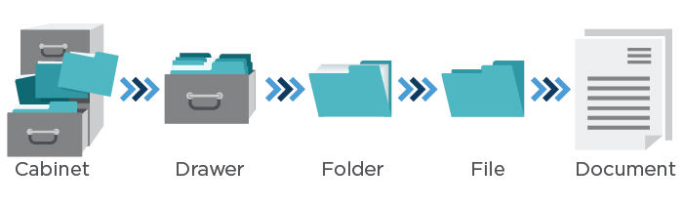  
  
A well-organized site hierarchy also helps the search engines better understand the semantic relationships between the sections of the site. This gets reinforced by other key site elements like XML Sitemaps, HTML site maps, and breadcrumbs, all of which can help neatly tie the overall site structure together.

[Tweet “Well-structured site architecture helps search engines understand your site. Learn SEO audits at”]

**2. Basic Health Checks**

Basic health checks can provide quick red flags when a problem emerges, so it’s good to do these on a regular basis (even more often than you do a full audit). Here are four steps you can take to get a diagnosis of how a website is doing in the search engine results:

1. Ensure Google Search Console and Bing Webmaster Tools accounts have been verified for the domain (and any subdomains, for mobile or other content areas). Google and Bing also offer site owner validation that allows you to see how the search engines view a site. Then, check these on a regular basis to see if you’ve received any messages from the search engine. If the site has been hit by a penalty from Google, you’ll see a message, and you’ll want to get to that as soon as possible. They’ll also let you know if the site has been hacked.
2. Find out how many of a website’s pages appear to be in the search index. You can do this by going to Google Search Console as follows: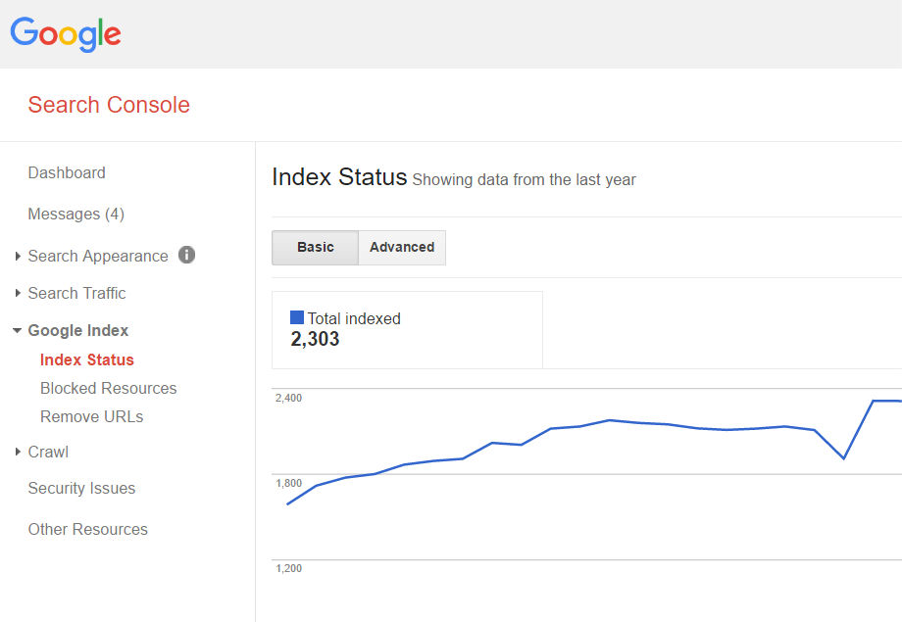Has this number changed in an unexpected way since you last saw it? Sudden changes could indicate a problem. Also, does it seem like it matches up approximately with the number of pages you think exist?I wouldn’t worry about it being 20 percent smaller or larger than you think, but if it’s double, triple or more, or only about 20 percent of the site, you probably want to understand why.
3. Go into Google Search Console to make sure the cached versions of a website’s pages look the same as the live versions. Below you can see an example of this using a page on the Perficient Digital web site.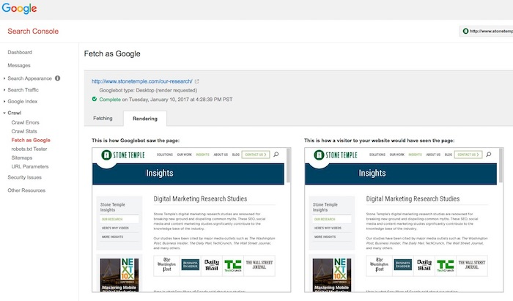
4. Test searches of the website’s branded terms to make sure the site is ranking for them. If not, it could indicate a penalty. Check the Google Search Console/Bing Webmaster Tools accounts to see if there are any identifiable penalties.

[Tweet “Learn how to do a basic site health check as part of an #SEO audit.”]

**3. Keyword Health Checks**

You’ll want to perform an analysis of the keywords you’re targeting on the site. This can be accomplished by many of the various SEO tools available. One thing to look for in general is if more than one page is targeting or showing up in the search results for the same keyword (aka “keyword cannibalization”).  
  
You can also use Search Console to see what keywords are driving traffic to the site. If you see critical keywords that used to receive traffic are no longer working (the rankings dropped) that could be a sign of a problem.

On the positive site of the ledger, look for “striking distance” keywords, those that rank in positions from five to 20 or so. These might be keywords where some level of optimization could move them up in the rankings. If you can move from position five to three or 15 to eight on a major keyword, that could result in valuable extra traffic and provide reasonably high ROI for the effort involved.

[Tweet “For great #SEO opportunities, look for striking distance keywords. Learn more at”]

**4. Content Review**

Here, we’re looking for a couple things:

1. **Content depth, quality, and optimization:** Do the pages have enough quality information to satisfy a searcher? You want to make sure the number of pages with little or “thin” content is small compared to those with substantial content. There are many ways to generate thin content.One example is a site that has image galleries with separate URLs for each image. Another is a site with city pages related to their business in hundreds, or thousands, of locations where they don’t do business, and where there is really no local aspect to the product or services they are offering on their site. Google has no interested in indexing all those versions, so you shouldn’t be asking them to do so!This is often one of the most underappreciated aspects of SEO. At Perficient Digital, we’ve taken existing content on pages and rewritten it, and seen substantial traffic lifts. In more than one case, we’ve done this on more than 100 pages of a site and seen traffic gains of more than 150 percent!
2. **Duplicate content:** A lot of websites have duplicate content without even realizing it. One of the first things to check is that the “www” version of the site and the “non-www” version do not exist at the same time (do they both resolve?). This can also happen with “http” and “https” versions of a site. Pick one version and 301 redirect the other to it. You can also set the [preferred domain in Google Search Console](https://support.google.com/webmasters/answer/44231?hl=en) (but still do the redirects even if you do this).

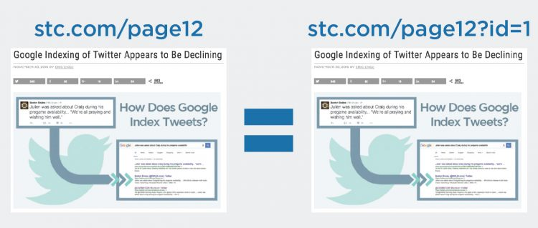

1. **Ad Density:** Review the pages of your site to assess if you’re overdoing it with your advertising efforts. Google doesn’t like sites that have too many ads above the fold. A best practice to keep in mind is that the user should be able to get a substantial amount of the content they were looking for above the fold.

[Tweet “A thorough content review is an essential part of any #SEO audit. Learn more at”]

**5. URL Names**

Website URLs should be “clean,” short and descriptive of the main idea of the page *and* indicate where a person is at in the website. So, make sure this is part of the SEO audit. Ensuring URLs are constructed well is helpful for both website users and search engines to orient themselves.

For example: www.site.com/outerwear/mens/hats

[](https://blogs.perficient.com/covid-19-digital-insight-for-enterprise-action/)

[COVID-19: Digital Insights For Enterprise Action](https://blogs.perficient.com/covid-19-digital-insight-for-enterprise-action/)

Access Perficient’s latest insights into how you can leverage digital technologies to not only respond to the pandemic, but drive your operations forward and deliver experiences your customers need.

[**Get Informed**](https://blogs.perficient.com/covid-19-digital-insight-for-enterprise-action/)

[Tweet “URLs should be clean, short, and descriptive of the page main idea. More at”]

It’s a good idea to include the main keyword for the web page in the URL, but never try to keyword-stuff (for example, www.site.com/outerwear/mens/hat-hats-hats-for-men).

Another consideration are URLs that have tracking parameters on them. Please *don’t ever do this* on a website! There are many ways to implement tracking on a site, and using parameters in the URLs is *the worst way* to do this.

If a website is doing this today, you’ll want to go through a project to remove the tracking parameters from the URLs, and switch to some other method for tracking.

On the other hand, perhaps the URLs are only moderately suboptimal, such as this one:  
  
http://www.site.com?category=428&product=80328

In cases like this, I don’t think that changing the URLs is that urgent. I’d wait until you’re in the midst of another larger site project at the same time (like a redesign).

**6. URL Redirects**

It’s a common best practice to ensure that a web page that no longer needs to exist on a website be redirected to the next most relevant live web page using a [301 redirect](https://support.google.com/webmasters/answer/93633?hl=en). There are other redirect types that exist as well, so be sure to understand the various types and how they function before using any of them.

[Tweet “Be sure to redirect pages that no longer need to be indexed in search to more useful pages. Learn how”]

Google recommends that you use 301 redirects because they indicate a page has permanently moved from one location to another, and other redirects, such as a 302, are used to signal that the page relocation is only temporary. If you use the wrong type of redirect, Google may keep the wrong page in its index.

It used to be the case that much less than 100 percent of the PageRank transferred to the new page through a redirect. In 2016, however, Google came out with a statement that there would be no PageRank value lost using any of the [3XX redirects](http://searchengineland.com/google-no-pagerank-dilution-using-301-302-30x-redirects-anymore-254608).  
  
To help check redirects, you can use tools like [Redirect Check](http://redirectcheck.com/) or RedirectChecker.org.  
  
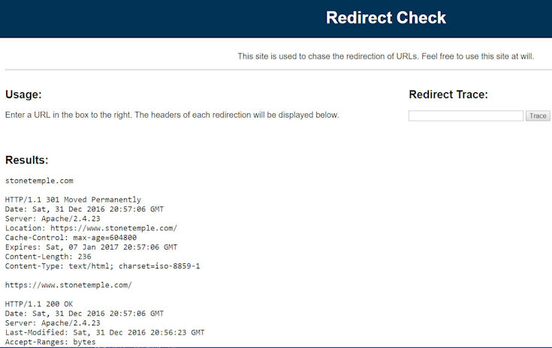

**7. Meta Tags Review**

Each and every web page on a site should have unique title tags and meta descriptions tags—the tags that make up the meta information that helps the search engines understand what the page is about.  
  
[Tweet “Make sure every page on your site has unique title and description tags. Learn more at”]  
  
This gives the website the ability to suggest to the search engines what text to use as the [description of its pages in the search results](https://support.google.com/webmasters/answer/35624?hl=en)(versus search engines like Google generating an “autosnippet,” which may not be as optimal).  
  
It may also help avoid some pages of the website from being filtered out of the search results if search engines use the meta information to help detect duplicate content.  
  
You’ll also want to take this opportunity to check for a [robots metatag](https://developers.google.com/webmasters/control-crawl-index/docs/robots_meta_tag) on the pages of the site. If you find one, there could be trouble. For example, an unintentional “noindex” or “nofollow” value could adversely affect your SEO efforts.

**8. Sitemaps and robots.txt Verification**

It’s important to check the XML Sitemap and robots.txt files to make sure they are in good order. Is the XML Sitemap up to date? Is the robots.txt file blocking the crawling of sections of a site that you don’t want it to? You can use a feature in the Google Search Console to test the [robots.txt file](https://support.google.com/webmasters/answer/6062608?hl=en). You can also test and add a [Sitemap file](https://support.google.com/webmasters/answer/156184?hl=en) there as well.

**9. Image Alt Attributes**

Alt attributes for the images on a website help describe what the image is about. This is helpful for two reasons:

1. I. Search engines cannot “see” image files the way a human would, so they need extra data to understand the content of the image.
2. II. Web users with disabilities, like those who are blind, often use screen-reading software that will help describe the elements on a web page, images being one of them, and these programs make use of the alt attributes.

It doesn’t hurt to use keyword-rich descriptions in the attributes and file names when it’s relevant to the actual image, but you should never keyword-stuff.

**10. Mobile Friendliness**

The amount of people that are searching and purchasing on their mobile devices is growing each year. At Perficient Digital, we have clients who get more than 70 percent of their traffic from mobile devices. Google has seen this coming for a long time, and has been pushing for websites to become mobile friendly for years.  
  
Because the mobile device is such a key player in search today, at the time of writing, Google has declared it will have a [mobile-first index](http://searchengineland.com/faq-google-mobile-first-index-262751). What that means is that it will rank search results based on the mobile version of a website first, even for desktop users.  
  
One key aspect of a mobile-first strategy from Google is that its primary crawl will be of the mobile version of a website, and that means Google will be using the mobile crawl to discover pages on a site.  
  
Most companies have built their desktop site to aid Google in discovering content, and their mobile site purely from a UX perspective. As a result, the crawl of a mobile site might be quite poor from a content discovery perspective.  
  
Make sure to include a crawl of the mobile site as a key part of any audit of a site. Then compare the mobile crawl results with the crawl of the desktop site.  
  
[Tweet “It is now essential for an SEO audit to include a mobile crawl of your site. Find out why at”]  
  
If a website doesn’t have a mobile version, Google has said it will still crawl and rank the desktop version; however, not having mobile-friendly content means a website may not rank as well in the search results.  
  
While there are a few different technical approaches to creating a mobile-friendly website, Google has recommended that websites use [responsive design](https://developers.google.com/webmasters/mobile-sites/mobile-seo/). There’s plenty of documentation on how to do that coming directly from Google, as well as tools that can help gauge a website’s mobile experience, [like this one](https://search.google.com/search-console/mobile-friendly).  
  
It’s worth mentioning Google’s [accelerated mobile pages (AMP)](http://searchengineland.com/amp-breaks-news-main-google-search-results-254965) here as well. This effort by Google is to give website publishers the ability to make their web content even faster to users.  
  
While Google has said that AMP pages won’t receive a boost in ranking at the time of writing, page speed is, however, a signal. The complexity of the technical implementation of AMP pages is one of the reasons some may choose not to explore it.  
  
Another way to create mobile experiences is via [progressive web apps](https://developers.google.com/web/progressive-web-apps/), which is an up-and-coming way to provide mobile app-like experiences on the web via the browser (without having to download an app).  
  
The main benefit is the ability to access specific parts of a website in a way similar to what traditional apps can.

**11. Site Speed**

[Site speed is one of the signals](https://webmasters.googleblog.com/2010/04/using-site-speed-in-web-search-ranking.html) in Google’s ranking algorithm. Slow load times can cause the crawling and indexing of a site to be slower, and can increase bounce rates on a website.  
  
Historically, this has only been a ranking factor when site speeds were *very* slow, but Google has been making noise that it will become more important over time. Google’s John Mueller has also indicated that a site that is too slow, and which is nominally mobile-friendly, may now be deemed as [non-mobile friendly](https://www.seroundtable.com/google-slow-pages-not-mobile-friendly-23203.html). However, currently, mobile-age speed is not currently treated by Google as a ranking factor.  
  
[Tweet “Site speed will become increasingly important as a search factor. Are you ready?”]  
  
In fact, site speed has become such an important element of the overall user experience, especially in mobile, that Google has said it wants above-the-fold content for mobile users to render in [one second or less](https://developers.google.com/speed/docs/insights/mobile).  
  
To help people get more visibility into site speed, Google offers tools such as the [PageSpeed Insights tool](https://developers.google.com/speed/pagespeed/insights/) and the site speed reports found in [Google Analytics](https://support.google.com/analytics/answer/1205784?hl=en).

**12. Links**

Here, we’re looking at links in a couple different ways: internal links (those on the website itself) and external links (other sites linking to the website).  
  
**Internal Links**First, look for pages that have excessive links. You may want to minimize those. Second, make sure the web pages use anchor text intelligently without abusing it or it could look spammy to search engines. For example, if you have a link to the home page in the global navigation, call it “Home” instead of picking your juiciest keyword.  
  
Internal links are what define the overall hierarchy of a site. The site might, for example, look like this:  
  
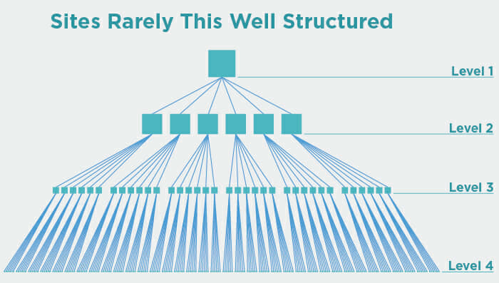

The site above obviously has a well-defined structure, and that’s good. But in practice, sites rarely look like this, and some level of deviation from this is perfectly fine.

A home page may link directly to some of the company’s top products, as shown in Level 4 of the image, and that’s fine. However, it’s a problem if the site has a highly convoluted structure that has many pages that can only be reached after a large number of clicks if you try to navigate to them from the home page, or if each page is linking to too many other pages.  
  
Look for these types of issues and try to resolve them to create something with a cleaner hierarchy.  
  
[Tweet “Make sure your site has a clean internal link structure. Learn more at”]

**External links**  
  
Also known as inbound links or backlinks, you’ll want to perform an analysis to ensure there aren’t any problems there, like a history of purchased links, irrelevant links, and links that look spammy.  
  
You can use tools like [Open Site Explorer](https://moz.com/researchtools/ose/), [Majestic SEO](https://majestic.com/), [Ahrefs Site Explorer](https://ahrefs.com/), [SEMRush](https://www.semrush.com/), and the Google Search Console/Bing Webmaster Tools accounts to collect data about links.

Personally, I like to use all of these sources, collect all of their output data, dedupe it and build one master list. None of the tools provides a complete list, so using them all will get you the best possible picture.

Look for patterns in the anchor text, like if too many of the links have a critical keyword for the site in them. Unless the critical keyword happens to also be the name of the company, this is a sure sign of trouble.

Also, check that there are links to pages other than the home page. Too many of these are another sure sign of trouble in the backlink profile. Lastly, check how the backlink profile for the site compares to the backlink profiles of its major competitors.

Make sure that there are enough external links to the site, and that there are enough high-quality links in the mix.

**13. Subdomains**

Historically, it’s been believed that subdomains do not benefit from the primary domain’s full trust and link authority. This was largely due to the fact that a subdomain could be under the control of a different party, and therefore in the search engine’s eyes, it needed to be separately evaluated.

For an example of a domain that allows third parties to operate subdomains of their site, consider Blogger.com, that allows people to set up their own blogs and operate them as subdomains of Blogspot.com.

For the most part, this is not really true today, and search engines are extremely good at recognizing whether or not the subdomain really is a part of the main domain, or if it’s independently operated.  
  
I still recommend using a subfolder over a subdomain as the default approach to adding new categories of content to a site., However, if you already have it on a subdomain, I would *not* move it to a subfolder unless you have clear evidence of a problem, as there is a cost to site moves, and the upside of making the move is not enough to pay that cost.

[Tweet “You should prefer subfolders over subdomains when structuring a new site. Find out why at”]  
  
For purposes of an audit, you need to make sure you include subdomains within the audit. As part of this, make sure your crawl covers them, and check analytics data to see if there is any clear evidence of a problem, such as it’s getting very little traffic, or recent material traffic drops.

For more on subdomains and their effect on SEO, see [Everything You Need to Know About Subfolders, Subdomains, and Microsites for SEO](https://www.stonetemple.com/subfolders-subdomains-microsites-and-seo/).

**14. Geolocation**

For websites that aim to rank locally, for example, a chiropractor that’s established in San Francisco and wants to be found for “San Francisco chiropractor,” you’ll want to consider things like making sure the business address is on every page of the site, and claiming and ensuring the validity of the Google Places listings.

Beyond local businesses, websites that target specific countries or multiple countries with multiple languages have a whole host of best practice considerations to contend with.  
  
These include things like understanding how to use hreflang tags properly, and attracting attention (such as links) from within each country where products and services are sold by the business.

**15. Code Quality**

A website with clean code that allows the search engines to crawl it with ease enhances the experience for the crawlers. [W3C validation](http://validator.w3.org/) is the “gold standard” for performing a checkup on the website’s code, but is not really required from an SEO perspective (if search engines punished sites for poor coding practices, there might not be much left to show in the search results). Nonetheless, clean coding improves the maintainability of a site, and reduces the chances of errors (including SEO errors) creeping into the site.

**Q-3[A]ONE MARK:**

1]what is microsites?

a. a Microsite is a website separate from the businesses' main homepage or URL that contains branded content.

You can use a microsite when: You want to have a place whose content caters only to one product. You're running a marketing campaign and want more control over the design and navigation of the related web pages.

2]CDN stand for- content delivery network

3]S1FR STAND FOR- Scalable Inman Flash Replacement

4]XML sitemaps are uually available in-

The Sitemaps protocol allows a webmaster to inform search engines about URLs on a website that are available for crawling.

**Q-3[B]TWO MARK:**

1]what is A/B split testing?

a. A/B testing (also known as split testing or bucket testing) is a method of comparing two versions of a webpage or app against each other to determine which one performs better.

A/B testing lets you know what words, phrases, images, videos, testimonials, and other elements work best. Even the simplest changes can impact conversion rates.

2]when to use subdomain and subfolder?

a. . A subdomain is a division or alias of your domain that can be used to organize your existing website into a separate site.

Subfolder:

**Q-3[C]THREE MARK:**

1]explain robots.txt file with example

a. A robots.txt file tells search engine crawlers which pages or files the crawler can or can't request from your site. This is used mainly to avoid overloading your site .

robots.txt is used primarily to manage crawler traffic to your site, and usually to keep a page off Google, depending on the file type:

In short, a Robots.txt file controls how search engines access your website.

This text file contains “directives” which dictate to search engines which pages are to “Allow” and “Disallow” search engine access.

Basic format:

User-agent: [user-agent name]Disallow: [URL string not to be crawled]

• In order to be found, a robots.txt file must be placed in a website’s top-level directory.

• Robots.txt is case sensitive: the file must be named “robots.txt” (not Robots.txt, robots.TXT, or otherwise).

• Some user agents (robots) may choose to ignore your robots.txt file. This is especially common with more nefarious crawlers like malware robots or email address scrapers.

• The /robots.txt file is a publicly available: just add /robots.txt to the end of any root domain to see that website’s directives (if that site has a robots.txt file!). This means that anyone can see what pages you do or don’t want to be crawled, so don’t use them to hide private user information.

• Each subdomain on a root domain uses separate robots.txt files. This means that both blog.example.com and example.com should have their own robots.txt files (at blog.example.com/robots.txt and example.com/robots.txt).

• It’s generally a best practice to indicate the location of any sitemaps associated with this domain at the bottom of the robots.txt file.

Example:

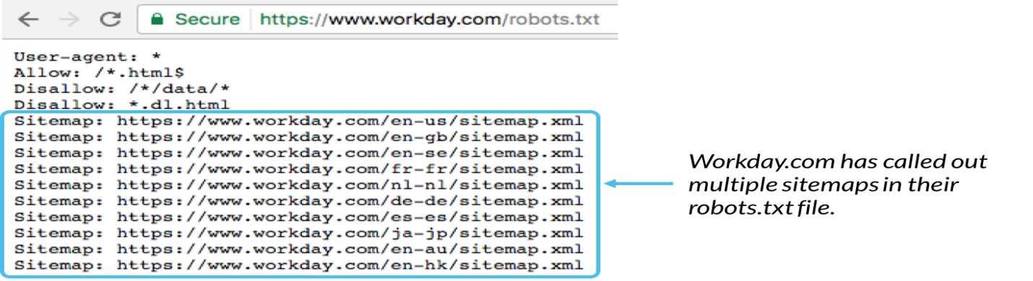

2]what is duplicate content?list out various issues.

a. Duplicate content is content that's similar or exact copies of content on other websites or on different pages on the same website.

### Session IDs

You often want to keep track of your visitors and allow them, for instance, to store items they want to buy in a shopping cart. In order to do that, you have to give them a ‘session.’ A session is a brief history of what the visitor did on your site and can contain things like the items in their shopping cart. To maintain that session as a visitor clicks from one page to another, the unique identifier for that session – called the Session ID – needs to be stored somewhere. The most common solution is to do that with cookies. However, search engines don’t usually store cookies.

At that point, some systems fall back to using Session IDs in the URL. This means that every internal link on the website gets that Session ID added to its URL, and because that Session ID is unique to that session, it creates a new URL, and therefore duplicate content.

### URL parameters used for tracking and sorting

Another cause of duplicate content is using URL parameters that do not change the content of a page, for instance in tracking links. You see, to a search engine, http://www.example.com/keyword-x/ and http://www.example.com/keyword-x/?source=rss are not the same URL. The latter might allow you to track what source people came from, but it might also make it harder for you to rank well – very much an unwanted side effect!

This doesn’t just go for tracking parameters, of course. It goes for every parameter you can add to a URL that doesn’t change the vital piece of content, whether that parameter is for ‘changing the sorting on a set of products’ or for ‘showing another sidebar’: all of them cause duplicate content.

### Scrapers and content syndication

Most of the reasons for duplicate content are either the ‘fault’ of you or your website. Sometimes, however, other websites use your content, with or without your consent. They don’t always link to your original article, and therefore the search engine doesn’t ‘get’ it and has to deal with yet another version of the same article. The more popular your site becomes, the more scrapers you’ll get, making this problem bigger and bigger.

### Order of parameters

Another common cause is that a CMS doesn’t use nice clean URLs, but rather URLs like /?id=1&cat=2, where ID refers to the article and cat refers to the category. The URL /?cat=2&id=1 will render the same results in most website systems, but they’re completely different for a search engine.

### Comment pagination

 In my beloved WordPress, but also in some other systems, there is an option to paginate your comments. This leads to the content being duplicated across the article URL, and the article URL + /comment-page-1/, /comment-page-2/ etc.

### Printer-friendly pages

If your content management system creates printer-friendly pages and you link to those from your article pages, Google will usually find them, unless you specifically block them. Now, ask yourself: Which version do you want Google to show? The one with your ads and peripheral content, or the one that only shows your article?

### WWW vs. non-WWW

This is one of the oldest in the book, but sometimes search engines still get it wrong: WWW vs. non-WWW duplicate content, when both versions of your site are accessible. Another, less common situation but one I’ve seen as well is HTTP vs. [HTTPS](https://yoast.com/what-is-https/) duplicate content, where the same content is served out over both.

**Q-3[D]FIVE MARK:**

1]what is cms?list out the issues to consider while using cms.

a. Picking a CMS (content management system) platform for your website is a smart idea. And there are many good content management systems to choose from that offer you the ability to update and control content on your website without advanced technical knowledge.

* They don't allow for title tag customization. ...
* Long, URL's that aren't static. ...
* Not allowing meta tag customization. ...
* Not allowing flexibility of internal anchor texts. ...
* Not enabling custom HTML tags. ...
* Not allowing for 301 redirects. ...
* No RSS pinging. ...
* Poor image handling.

1. **They don’t allow for title tag customization.**  
   A search engine friendly CMS allows for all title tags to be customized (page specifically).
2. **Long, URL’s that aren’t static.**  
   URLs pose problems for SEO when it comes to CMS platforms—ideally your platform should assist with URL creation and allow for custom keyword rich URLs, hyphenated for separation.  Your CMS platform should auto generate titles based on posting titles (if you’re lazy) or enable manual changing of URLs.
3. **Not allowing meta tag customization.**  
   Both meta tags, meta descriptions, and robot tags are critical for a good SEO friendly CMS.
4. **Not allowing flexibility of internal anchor texts**Having the ability to customize anchor text on internal links is critical.  In order to optimize your website, your CMS platform should provide the flexibility to handle custom input.
5. **Not enabling custom HTML tags.**  
   A SEO friendly CMS system has the ability to offer extra functionality when it comes to “nofollow” links, HTML tags, or other subheadline or headline tags.
6. **Not allowing for 301 redirects.**  
   Allowing for 301 redirects are an absolute must for SEO.  Unfortunately, some CMS platforms lack this feature—these redirects are crucial for taking care of expired content, pages with newer versions, solving duplicate content issues, multiple domain issues, etc…
7. **No RSS pinging.**  
   A CMS that doesn’t allow for pinging limits exposure—CMS that allow pinging are useful for articles, press releases, pages, and blog posts.
8. **Poor image handling.**  
   Alt tags on images are a must for SEO—they serve as “anchor text” for the search engines.
9. **Poor categorization.**  
   Just like URL creation, categorization should be flexible.  Any CMS platforms offering customizable navigation will be a SEO success.

2]list out the places that can be used for keyword targeting?

a.

**Q-4[A]ONE MARK:**

1]what is keyword research?

a. . Keyword research is an SEO practice of finding, analyzing and using the phrases people use to search for information on the internet.

2]what is short tail keyword?

a. Short-tail keywords are much more general search queries consisting of one or two words, while long-tail keywords consist of three to five or even more words.

3]what is sticky post?

a. A “sticky” post is one that always appears at the top regardless of the date/time posted. The “sticky” feature is available in some blog systems by default (e.g. Blogger.com) and in others through the use of a plugin (e.g. the Adhesive plugin for WordPress).

4]what is local guide?

a. Local Guides is a global community of explorers who write reviews, share photos, answer questions, add or edit places, and check facts on Google Maps. Millions of people rely on contributions like yours to decide where to go and what to do.

**Q-4[B]TWO MARK:**

1]what is keyword density analysis?

a. Keyword density refers to the number of times a keyword appears on a given webpage or within a piece of content as a ratio or percentage of the overall word count.

Keyword density is an element of keyword optimization that refers to the number of times a target keyword is used on a webpage. It is a percentage that represents how frequently the target keyword appears relative to the number of words on the page.

2]what is blog optimization?

a. **Blog Optimization**

Blogs are great publishing platforms for those who want to write articles on a regular basis. First, they make it easy to publish the content. Authors only need to log in and use a relatively simple set of menu choices to input what they want to publish, preview it, and then proceed to publish it. It is far easier than coding your own HTML pages by hand.

In fact, it is so easy that entire websites have been built using WordPress as the sole publishing platform. These sites are also typically easy to set up and configure. The world’s most popular blog platform is [WordPress](http://www.wordpress.com/), but the blog platforms from [Moveable Type](http://www.moveabletype.org/) and [TypePad](http://www.typepad.com/) are also popular.

Blogs are inherently social in nature, and a host of social marketing benefits come from blogs. Enabling comments allows for interaction with your readers, and bloggers tend to have a significant level of interaction. For example, one blogger may write a post that reacts to or comments on another blogger’s post. A lot of cross-linking takes place, with one blogger citing another.

Working this aspect of blogging as a social media platform is beyond the scope of this book. Nonetheless, be aware that a blog is an opportunity to establish yourself as an expert in a topic area, and to engage in a give-and-take activity that can dramatically change the visibility of your business.

In addition to these huge benefits, blogs can also bring you search engine and/or blog search engine traffic when they are properly optimized.

**Q-4[C]THREE MARK:**

1]explain traditional approach for keyword research?

a. Traditional keyword research is an old school approach to finding low-competition, high search volume keywords, and it's one that's still favored by many SEO's and content marketers today.

Keyword research is a core SEO task that involves identifying popular words and phrases people enter into search engines -make in an attempt to figure out what to rank for.

2]explain local search in detail.

a.

**Q-4[D]FIVE MARK:**

1]explain any keyword research tool.

a. 5.10

2]explain news,blog and feed search

a. **news:**The news search engines are looking for content that is in the form of either a news story or a feature story. They also are looking to see that you are creating news content in reasonable volume—a minimum of 10 articles per week. News sites are looking for news sources (i.e., sites), not individual news pieces. In addition, as mentioned previously, be aware that both Yahoo! News and Google News very rarely accept new sources. Investing in building a news feed to try to get into these new search engines is an iffy proposition at best, and should only be pursued if you are already committed to producing very high quality news content.

Guidelines for the content are the same as they are for traditional news. The articles should have a catchy, keyword-rich headline and a strong opening paragraph.

The opening paragraph should draw the reader in so that he will read the rest of the article. In traditional news, the main compelling point is put forth at the start, and the discussion continues through other points of descending importance. The news piece should end with a strong concluding paragraph that reviews the major points of the article.

**Blog Optimization**

Blogs are great publishing platforms for those who want to write articles on a regular basis. First, they make it easy to publish the content. Authors only need to log in and use a relatively simple set of menu choices to input what they want to publish, preview it, and then proceed to publish it. It is far easier than coding your own HTML pages by hand.

In fact, it is so easy that entire websites have been built using WordPress as the sole publishing platform. These sites are also typically easy to set up and configure. The world’s most popular blog platform is [WordPress](http://www.wordpress.com/), but the blog platforms from [Moveable Type](http://www.moveabletype.org/) and [TypePad](http://www.typepad.com/) are also popular.

Blogs are inherently social in nature, and a host of social marketing benefits come from blogs. Enabling comments allows for interaction with your readers, and bloggers tend to have a significant level of interaction. For example, one blogger may write a post that reacts to or comments on another blogger’s post. A lot of cross-linking takes place, with one blogger citing another.

Working this aspect of blogging as a social media platform is beyond the scope of this book. Nonetheless, be aware that a blog is an opportunity to establish yourself as an expert in a topic area, and to engage in a give-and-take activity that can dramatically change the visibility of your business.

In addition to these huge benefits, blogs can also bring you search engine and/or blog search engine traffic when they are properly optimized.

## Feed Optimization

Many people mistakenly lump blogs and RSS together, but RSS has infinitely more applications beyond just blogs. RSS feeds can also be used for reporting upon or announcing news alerts, your latest specials, clearance items, upcoming events, new stock arrivals, new articles, new tools and resources, search results, a book’s revision history, top 10 best sellers (as Amazon.com does in many of its product categories), project management activities, forum/listserv posts, and recently added downloads. A good place to start is with basic SEO practices, as we’ve outlined elsewhere in the book (providing good titles and descriptions, handling tracking URLs properly, etc.).

Here are the basics for RSS feed optimization:

* If practical, use the full text of your articles in your feeds, not summaries. A lot of users want to read the full article in the feed without having to click through to your site. This is a case where you need to focus more on the relationship with the user than on immediate financial goals.
* Consider multiple feeds. You can organize them by category, latest comments, comments by post, and so on.
* An RSS feed that contains enclosures (i.e., podcasts) can get into additional RSS directories and engines, as there are many specialized directories just for podcasts or other types of media.
* Make it easy to subscribe. Ideally, users should have to click only once to subscribe via their favorite aggregator. You can do this through “Add to ____” (My Yahoo!, Bloglines, Google Reader, etc.) buttons on your site. Also make sure to implement <link> tags for auto-discovery (e.g., <link rel="alternate" type="application/rss+xml" title="RSS" href="http://feeds.stephanspencer.com/scatterings" />) in the <head> section of your web pages.

**Q-5[A]ONE MARK:**

1]define voice search recognization

a. Voice recognize search essentially allows users to speak into a device as opposed to typing keywords into a search query to generate results 2]what is reputation monitoring?

a. Reputation management is the effort to influence what and how people think of a brand or person when viewed online. ... Either way, you will work to monitor and improve your reputation over time, often starting with improving your search engine results.

3]LUI stand for-

4]what is branded traffic?

a. Branded Traffic refers to any website traffic that comes from visitors who type in keywords that include any reference to your company's brand, such as your name.

**Q-5[B]TWO MARK:**

1]what is tracking cycle

a. SEO tracking is a critical component of search engine optimization which ... SEO is actually performing, you need to track each step of your sales cycle. ... For example, you can set up one phone number for Google AdWords, ...

* *tracking**cycle:produce,launch,measure,refine*
* *define an seo campaign and set goals*
* *establish a baseline*
* *collect data*
* *compare the baseline data to the new data*
* *discuss our strategy*
* *proceed with your project*
* *refine your compaign*

2]what is robot traffic analysis.

a.

**Q-5[C]THREE MARK:**

1]what is action tracking?explain activities for e-commerce site,blog and B2B.

a. Action Tracking is a method of logging progress on internet that is a cookie-based method to track actions and page visits.

2]explain measuring success is essential to the seo process.

a.Why Measuring Success Is Essential to the SEO Process

Although quantifying deliverables and measuring progress are important for external reporting purposes, it is just as important for SEO practitioners to measure the efficacy of their own efforts so they can make timely adjustments as necessary. As you will see in this chapter, numerous tools are available to aid in this process.

At the beginning of any SEO project, it is wise to establish baseline data points for the website. This includes the following:

* Quantifying organic search traffic by search engine and keyword
* Quantifying a baseline of the major keywords that are driving traffic by search engine
* Quantifying a breakout of what sections are getting the current organic search traffic by search engine and keyword
* Quantifying data on conversions broken down by search engine and keyword
* Identifying poorly performing pages
* Identifying the best-performing pages (in terms of traffic and conversions)
* Tracking search engine crawler activity on the site
* Determining the number of indexed pages
* Determining whether the indexed pages are getting search traffic
* Determining whether best-selling product pages are indexed and getting search traffic
* Identifying 404 error pages and external sites linking to these pages, if any

Remember: you cannot methodically improve what you cannot measure.

**Q-5[D]FIVE MARK:**

1]how can we determine project ROI?explain itz element.

a.

2]how search engine expert would surive increased market saturation and competition.

a.9.9